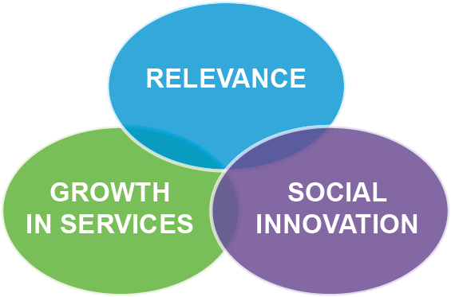**Role : Community Support Coordinator**

**Team Purpose**

The Community Services team is responsible for delivering community services that provide support to parents and families, enhance the Plunket brand locally and nationally and meet the needs of the local community.

**Position Purpose**

The Community Support Coordinator is accountable for coordinating, supporting and enabling Plunket people to deliver community based initiatives that help Plunket to achieve its goals and the fulfilment of our vision – In the first 1000 days we make the difference of a lifetime. The role works in partnership with the Community Services Leader, Plunket volunteers and employees to provide relevant services to the community and to strengthen and expand the volunteer network. This position reports to the Community Services Leader (CSL).

|  |  |  |
| --- | --- | --- |
| **My Role** | **Accountabilities** | **Outcomes** |
| **Business as Usual** | * Providing support to the CSL to grow and retain our volunteer base, through promotion of volunteering opportunities, recruitment, induction and development programmes * Developing and assisting with volunteer appreciation events throughout the year and ensuring all volunteers are recognised for their efforts * Being visible to volunteers, maintaining oversight of volunteer activity to ensure they are meeting desired outcomes, involving the Community Services Leader where appropriate * Maintaining effective systems and records of Plunket’s volunteer base and volunteer activity * Set up and maintenance of infrastructure and resources for volunteers to manage groups, parent to parent connections and other volunteer driven activity * Role modelling and educating volunteers in Plunket systems and way of working * Following up internal and external referrals relating to gaps in community need that could be met by volunteers, and matching the skills, experiences, and expectations of volunteers to positions available * Keeping records and submitting regular reports on group attendance and volunteer programme outcomes to the Community Services Leader * Maintaining an awareness of and promoting Plunket services, parenting groups and events to parents and to other providers in the community/health sector to encourage attendance and participation * Keeping key internal stakeholders up to date about additions and changes to Plunket services, groups, support and events * Raising staff awareness of the role and function of volunteers, keeping them updated on available community and volunteer services, and opportunities for volunteering | * Plunket is relevant for volunteers of today and opportunities for growth of the volunteer base for Plunket are maximised * Plunket has a strong brand image, its profile in the local community is high and people are aware of volunteering opportunities * Our volunteer network feel well supported, recognised and connected to Plunket and motivation for continuing commitment is maintained * Volunteers are informed and up to date on Plunket activity and are providing relevant support and services that are reflective of the local communities needs * Volunteers are taking ownership for delivering on accountabilities and are looking for ways to enhance community and parenting outcomes * Community services, groups, parenting support and events are well attended and supported by the local community * More parent to parent connections and parent to service connections are being made resulting in a healthy, well supported and close-knit communities * Volunteers and volunteering are recognised as a pivotal part of Plunket’s success in meeting community needs * Volunteer records and systems are well maintained and meaningful data is able to be used and obtained * Systems and processes are in place to promote good business practice to support volunteers in being accountable for delivering desired outcomes * Community services and volunteering opportunities are being marketed effectively internally and externally, resulting in community needs being met * Regular and meaningful reports and data is being produced and shared to promote the value of volunteering and outcomes to communities |
| **Leadership** | * Being an active participant of the Community Services Team, including attendance at team meetings and supporting the CSL to achieve area and community goals * Embedding One Plunket principles as an integral part of working and volunteering within the area and role modelling the desired culture and way of working * Providing a link and connection between Plunket volunteers and employees | * Effective working relationships with the volunteers and Community Services team and cohesive overview of Area activity maintained * Leading and living Plunket’s values helping to build the desired culture and way of working where One Plunket principles are an integral part of leadership and working within the the area * Volunteers and employees work effectively together to acheive common goals, understand where they fit and how their role contributes to Plunket objectives |
| **Business Plan** | * Contributing towards the development of strategy for the attraction, retention and recognition of volunteers * Working with the Community Services team and volunteers to ensure annual plans are achieved including providing support to Plunket Groups for annual planning and budgetting | * Area plan service delivery and support is responsive to community needs * National and area initiatives are understood and well supported by the volunteer network |

**Person Specification**

***Background/Experience***

* An understanding of the principles and practice of volunteering and volunteer coordination is highly desirable
* Strong relationship building capabilities, with proven experience in establishing trust and rapport with a wide range of people
* Well established networks with extensive knowledge of the local community
* Excellent communication skills, with experience in written and oral presentations, influencing and conflict management
* A focus on quality, continuous improvement and excellence

***Skills and Attributes***

* Understand the nature and timeframes of our volunteer network, with ability and willingness to travel within the Area on scheduled/as needed basis
* Be proactive and willing to seek wider input from available collective experience and skills
* Able to take initiative and think outside of the box in order to take advantage of opportunities as they arise
* Able to communicate clearly and succinctly to a wide range of people, making use of different communication channels
* Able to engage and think at a broad level to explore and understand trends, opportunities and risks that could affect volunteering
* Able to self manage, and have the flexibility to respond to and prioritise work as required and excellent time management skills
* Have the ability to identify what needs to be done, and to organise and motivate yourself to do it

## ACE-Ability

Plunket’s behavioural competency model is made up of three dimensions of personal behaviour - Connection to Plunket, Adaptability and Emotional Maturity.

*Connection to Plunket’s Direction*

Has a high level of energy and commitment to achieving Plunket’s vision

Has a broad range of engagement

Is committed to adapting and improving their own practice

*Adaptability*

* 1. *Thinking*
* Is comfortable with complexity and can think beyond the operational
* Can look beyond face value to see possibilities from different angles and viewpoints
* Keeps perspective
* Accepts and able to work with ambiguity and change

*b) Interpersonal*

* Is committed and capable of initiating and broadening professional and social networks
* Holds courage to face and deal with difficult people and issues

*Emotional Maturity*

* Is non-reactive and objective
* Understands the degree of influence in their role
* Understands own limitations